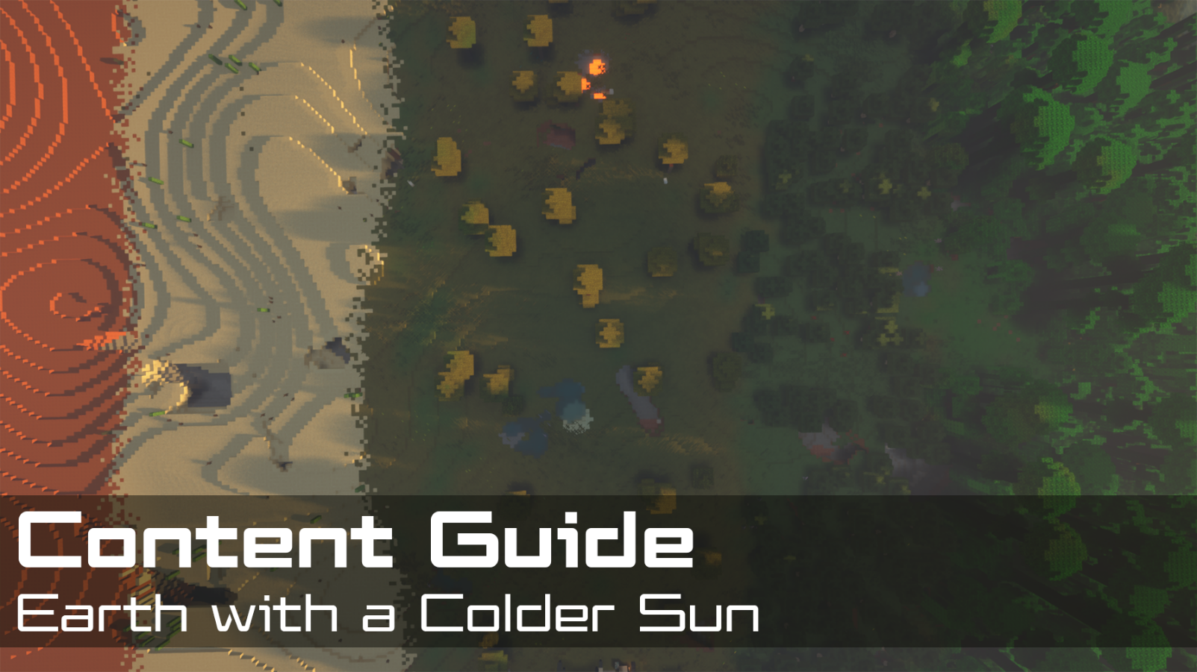
Contents  📖 Narrative Focus 3  World Overview 3  🎯 Objectives 4  🏫 Standards Alignment 4  📝 Assessments 5  💡 Tips for Instruction 6  🔭 Observable Concepts and Points of Interest 6  ❓ Expected Questions 7  🔬 Connected Classroom Activities 7  ☑️ World Quest Progression 7  🗺️ Maps 9  👩🏽‍🔬 NPC's and Their Roles 11 | How to Use This Guide  This content guide is intended for parents, librarians, teachers, and other educators who are interested in facilitating learning experiences with the WHIMC server, in home or classroom-based settings. It reviews all the critical components of a given WHIMC world as well as what might be learned in it.  This world is the 6th players encounter, for a full overview of world order, see the teacher guide home page.  More information about project WHIMC can be found on our website at whimc.org. Teachers and participants unfamiliar with computer-based Minecraft: Java Edition can learn how to install and control the game here as well.

📖 Narrative Focus
Even a relatively minor change to our sun can have major impacts on how life works, learners begin to understand the importance of elements like our rotation and tilt and stable but variable seasons.

World Overview
This world imagines Earth orbiting "Dimsun," a star cooler, redder, and less massive than our Sun. To stay warm enough for liquid water, Earth must orbit much closer — and that proximity changes a great deal.

Tidal Locking & a One-Faced World
- To sit in Dimsun's habitable zone, Earth orbits so close that the star's tides become enormous, far stronger than the Sun's tides on our Earth.
- These tides eventually slow Earth's rotation until the same side always faces Dimsun — one hemisphere in permanent day, the other in permanent night.
- This is the same process that locked our own Moon so one face always points at Earth.

The Habitable Ring (Greenbelt)
- The day side gets hot enough to evaporate huge amounts of ocean water; the night side is so cold that drifting clouds fall as snow that never melts.
- Over time, water migrates and freezes out on the dark side, leaving the day side dry
- The only place liquid surface water survives is a narrow ring at the terminator — the boundary between day and night — where sun-facing ice can melt. Life is concentrated in this strip.

Redder Light & Altered Photosynthesis
- A cooler star emits more of its energy as red and infrared light and less visible/blue light.
- Plant life would adapt to harvest this redder spectrum, likely appearing darker.
- A shorter, closer orbit means a much shorter year and likely no seasons.

🎯 Objectives
- Students will learn reasons behind the importance of Earth’s axis tilt as well as rotation speed, particularly that it’s not locked to the sun.
- Students will learn that life is possible even in extreme temperatures and the ways that people combat those temperatures and thrive.
- Students will learn about how power sources make use of what is available and appropriate for the environment, especially geothermal and solar options.

🏫 Standards Alignment
Next Generation Science Standards (reference)
- K-PS3-1: Make observations to determine the effect of sunlight on Earth’s surface.
- K-PS3.B: Conservation of Energy and Energy Transfer
- K-ESS2.D: Weather and Climate
- 1-ESS1.A: The Universe and its Stars
- 1-ESS1.B: earth and the Solar System
- 2-LS2.A: Interdependent Relationships in Ecosystems
- 2-ESS2.c: The Roles of Water in Earth’s Surface Processes
- 3-ESS2.D: Weather and Climate
- 4-ESS3.A: Natural Resources
- 5-ESS1-1: Support an argument that differences in the apparent brightness of the sun compared to other stars is due to their relative distances from Earth.
- 5-ESS1.A: The Universe and its Stars
- 5-ESS1.B: Earth and the Solar System
- 5-ESS2.C: The Roles of Water in Earth’s Surface Processes
- 5-ESS3.C: Human Impacts on Earth Systems
- MS-ESS-1: Develop and use a model of the Earth-sun-moon system to describe the cyclic patterns of lunar phases, eclipses of the sun and moon, and seasons.
- MS-ESS2-2: Construct and explanation based on evidence for how geoscience processes have changed Earth’s surface at varying time and spatial scales.
- MS-ESS1.A: The Universe and Its Stars
- MS-ESS1.B: Earth and the Solar System
- MS-ESS2-6: Develop and use a model to describe how unequal heating and rotation of the Earth cause patterns of atmospheric and oceanic circulation that determine regional climates.
- MS-ESS2.C: The Roles of Water in Earth’s Surface Processes
- MS-ESS2.D: Weather and Climate
- MS-ESS3.A: Natural Resources

📝 Assessments
During WHIMC camps, instructors provide opportunities for students to express what they have learned in whatever form is ability-matched and age appropriate. Examples of discussion or short answer questions are provided below in the form of ICAN Prompts and Self-Explanations.
Self-Explanations
Colder Sun Questions | Why is part of the world always hot and the other always cold? | What might be a good way to generate energy on Colder Sun? | Could humans survive on Colder Sun? Why?
Possible Answers | It is a tidally-locked planet, meaning that one side always faces the star. That side always receives heat from the star, while the opposite (night) side never receives heat from the star | Solar panels on hot side, or more creative answers like geothermal | Maybe in the habitable strip because it could have appropriate climate conditions and life

Quest participation can be an indicator of engagement. This map is part of the larger series of Explore [What-If] Earths and contains On the Edge. They are both required quests and just indicate a baseline minimum for completion, if participants complete the side quest Cave Life this indicates more exploration.
On every world there are main concepts and science variables that can be observed. Instructors can expect a minimum of 3 observations of substantive quality and 3 different science measures to consider a learner to be at a level of satisfactory engagement on Earth with a Colder Sun.
ICAN Prompts (retired)
ICAN tell you what Earth would be like if the sun is colder and reasons why. | ICAN share one question I have about a what-if world that I have seen.

💡 Tips for Instruction
- This world lends itself to pretty intuitive science tools use.
- If they fall into the jungle and get lost this is an outstanding opportunity to teach them how to teleport to one another.
- Keep kids from running around too much on the bridge – challenge them to find extremes.

🔭 Observable Concepts and Points of Interest
To see a list of all available science tools, simply type /sciencetools measure into the in-game chat, press space, and then use the arrow keys to scroll through the list of available options.
Global (regions: __global__ or perimeter on worlds ColderHabitableStrip, ColderCold, ColderHot)
/tides – slightly less than Earth
/year – time to orbit is 100 days
/tilt – 0 degrees, it’s tidally-locked
Habitable Strip (regions: poi_habitable_strip_* desert, savanna, temperate_forest, jungle, cold_taiga, snowy_edge)
All the variables that can change with different biomes = e.g. humidity, temperature, pressure
Order, color and composition of all the biome strips
Red-colored sun on horizon
Hot Side (regions: __global__ or perimeter on world ColderHot)
/temperature – value is slightly greater than 100 degrees Celsius
/humidity – 0.0%
/radiation – 13.3 mSv
Cave conditions will be different (region: poi_cshunderground)
Sun directly overhead
Cold Side (regions: __global__ or perimeter on world ColderCold)
/temperature – value is slightly less than -100 degrees Celsius
/humidity – between 7% and 10%
/radiation – 0.9 mSv
Cave conditions will be different (region: poi_cscunderground)
No visible sun
Visible geographic features
Power from solar panels and geothermal systems (region: poi_geothermal)
Life in caves (regions: poi_cscunderground, poi_cshunderground)

❓ Expected Questions
Questions Kids Might Ask | Questions Facilitators Might Ask
Where could I live on this planet?  Why is it so cold on this side?  Why is it so warm on this side?  Why do they need to live underground?  How do they get their energy here?  What is the temperature of the sun even though it’s colder?  Why is the sun so dark here? | What do you think night time feels like here?  Which side would you rather live on if you had to choose one?  What do the tides look like here?  What does habitability mean? What is a habitable zone?  Was there anything in this level that surprised you?  Where did you explore? Who did you meet?  What questions do you have?

🔬 Connected Classroom Activities
Use physical spherical objects which demo tidal locking (explanation here)
Explanations and lessons about why sunlight is the “color” that it is (demo here)
Lessons on how solar panels work (source)
Explanations and Explorations such as how Earth with a colder sun becomes tidally locked, star temperatures and compositions and growing plants in artificial light

☑️ World Quest Progression
In order to exit this world, players need to explore all three zones and make three separate observations, all of which are assigned by Jorge. They may also explore the caves as a side quest.

🗺️ Maps
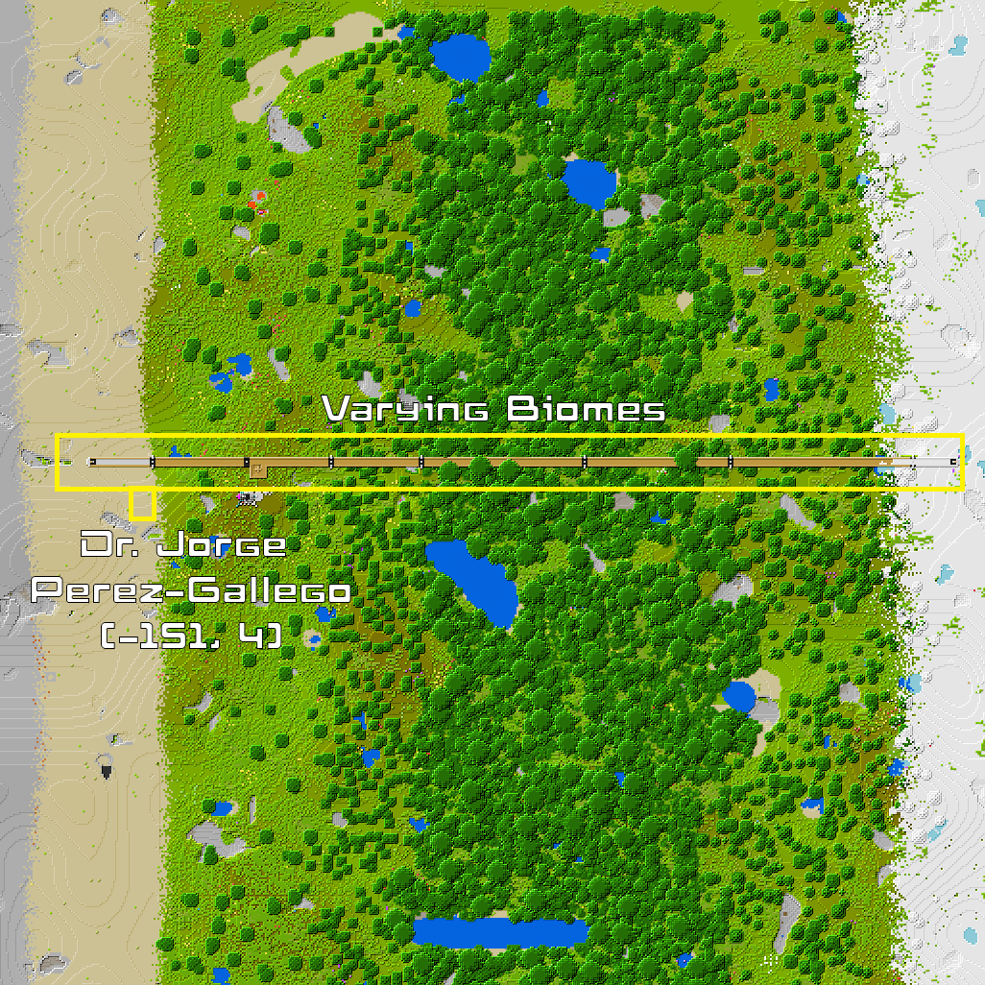
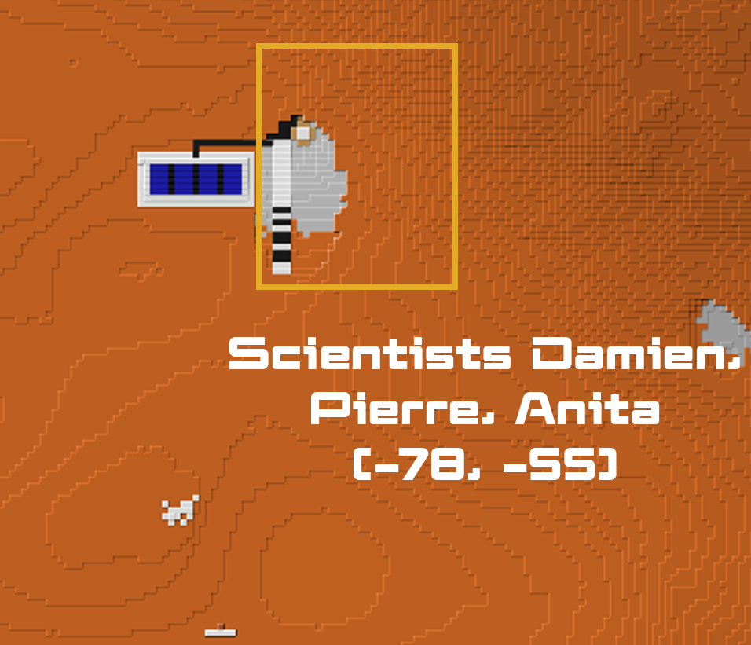
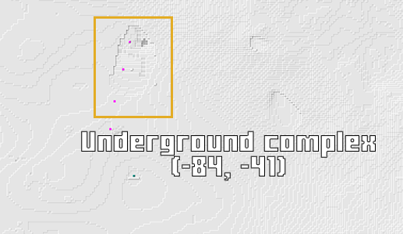

👩🏽‍🔬 NPC's and Their Roles
A non-player character (NPC) is a video game character that is controlled by the game's artificial intelligence (AI) rather than by a player. The NPC’s below are those that are tied to quests on the server or that offer relevant STEM information – there are others who may be present but not mentioned in this guide.
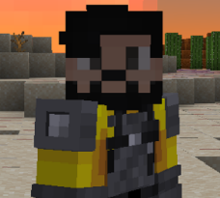 | Located at  x: -151  y: 67  z: 4  ID: 114 | [Artist-Astronomer] Dr. Jorge Perez-Gallego
 | Located at  x: -84  y: 51  z: -31  ID: 110 | [Travel Authority] Jack L. – Located on the cold side, Jack emphasizes the extreme cold and need to live underground, explains there's never any sunlight whatsoever; encourages players to talk to Vera.
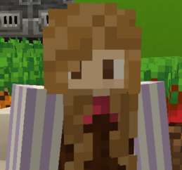 | Located at  x: -84  y: 51  z: -41  ID: 111 | [Botanist] Vera K. – Located on the cold side, Vera notes that they use geothermal energy to stay warm and grow food.
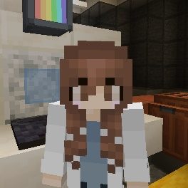 | Located at  x: -60  y: 51  z: -34  ID: 277 | [Hydro Engineer] – Located on the cold side, this engineer explains that she’s regulating the cooling system for the geothermal power, which is improved because of the climate outdoors.
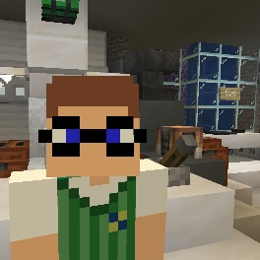 | Located at  x: -62  y: 51  z: -23  ID: 278 | [Power Controller] – Located on the cold side, this specialist notes that the hot water pulled from beneath the surface for turns turbines to generate power.
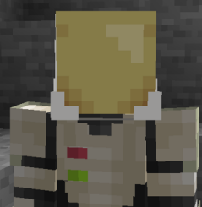 | Located at  x: -78  y: 60  z: -55  ID: 191 | [Team Leader] Damien K. – Located on the hot side, Damien talks about the difficulty in setting up underground accommodations, invites players to explore and meet the other NPCs.
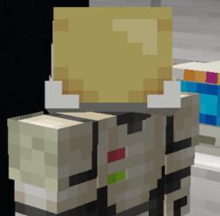 | Located at  x: -100  y: 76  z: -45  ID: 190 | [Electrical Engineer] Josephina R. – Located on the hot side, Josephina identifies the importance and ubiquity of solar power.
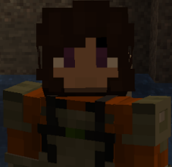 | Located at  x: -93  y: 41  z: -85  ID: 189 | [Hydrologist] Anita J. – Located on the hot side, Anita studies how underground water affects life.
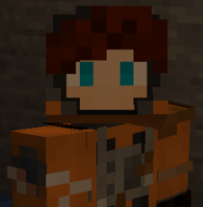 | Located at  x: -86  y: 46  z: -90  ID: 188 | [Xenobiologist] Pierre B. – Located on the hot side, Pierre identifies what Xenobiology is.

